**MOBILE APPLICATION FOR CREATE, SHARE, TRACE AND WALK THROUGH A ROUTE**

**REPORT**

**2014**

**SAVYA SRI PATHURI -16157518**

**SPNYB@MAIL.UMKC.EDU**

**4/6/2014**



**REPORT**

**A MOBILE APPLICATION FOR CREATING, SHARING, TRACING AND WALKING THROUGH A ROUTE .**

**1) Design:**

**Following are the architecture and class diagram of the application.**

**A) Architecture Diagram:**

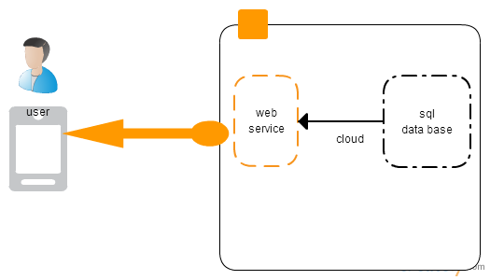

**B) Class Diagram:**

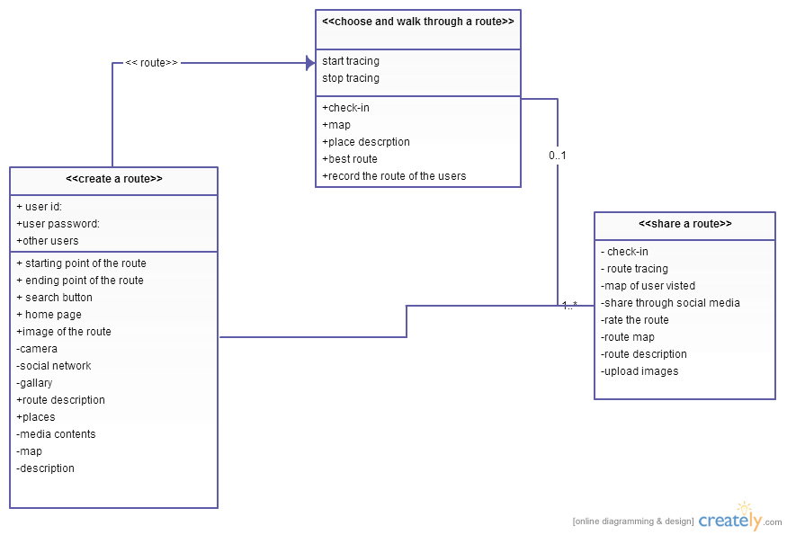

**2) Features Implemented**

**a) Mobile Service (own):**

**(i) Home page: home page of the application**

**(ii)create a route page: is this we can create a route based on starting and destination point**

**(iii)share a route page: we can share the user route by social media by uploading images, route map, route description.**

**(iv) trace a route page: we can trace the user route from where he/she started and where he/she is in current locations**

**(v) walk through a route page: here the clear map of route is shown where user walk through by check-in each place.**

**Mobile Service(Existing):**

**(i) Google map API: Used to search the places and display route to the user.**

**Please find below are the few screen shots for user interface:**

**1)This is the home page of the mobile application for creating, sharing tracing and walking through a route.**

**here i included 5 main buttons in home page**

**1) create a route**

**2) share a route**

**3) trace a route**

**4) walk through a route**

**5) history of browsed data**

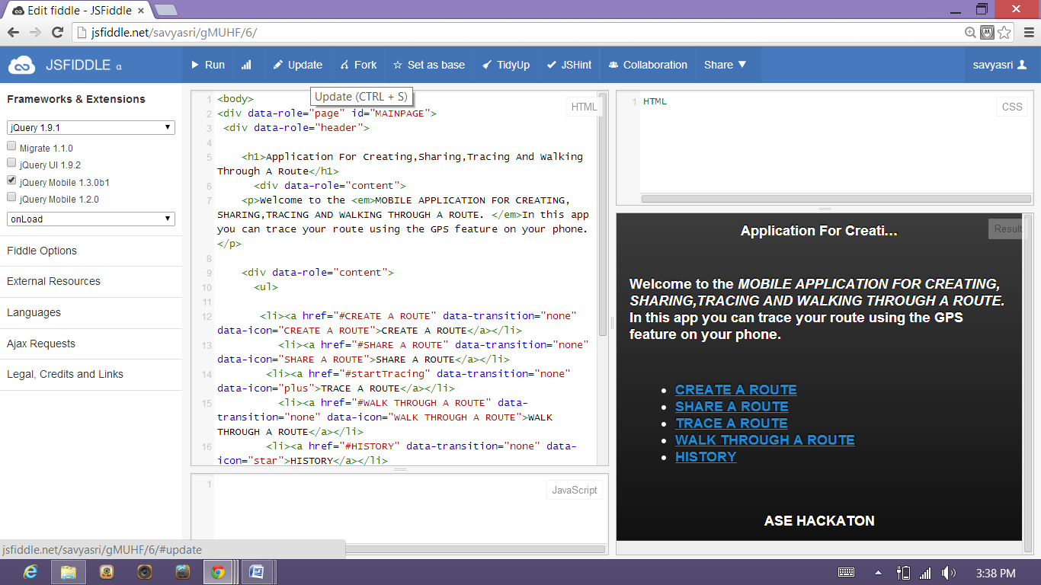

**2)**

**After clicking the create a route a below page appears**

**In this page we can create route, So we has starting point, destination point**

**After entering starting and destination point click on search button then route will be created.**

**If something is wrong we can return into homepage by clicking the home button.**

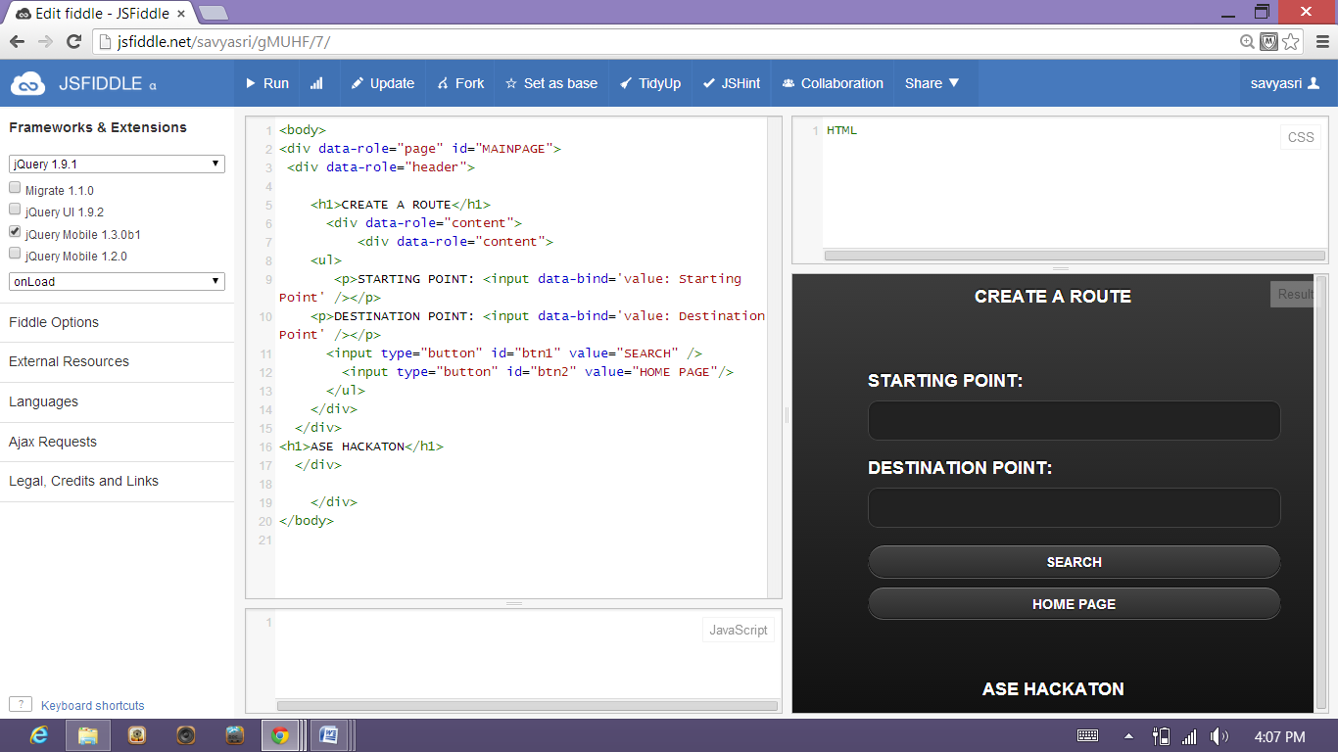

**3)**

**Next , coming to share a route page.**

**This page comes when we click share a route button from the home page.**

**In this share a route page the user can share his/her route to social media by check-in the place or he/she can share route map from where he/she started and where he/she in current location.**

**and also he/she can upload images of places or route or place description by clicking the following buttons.**

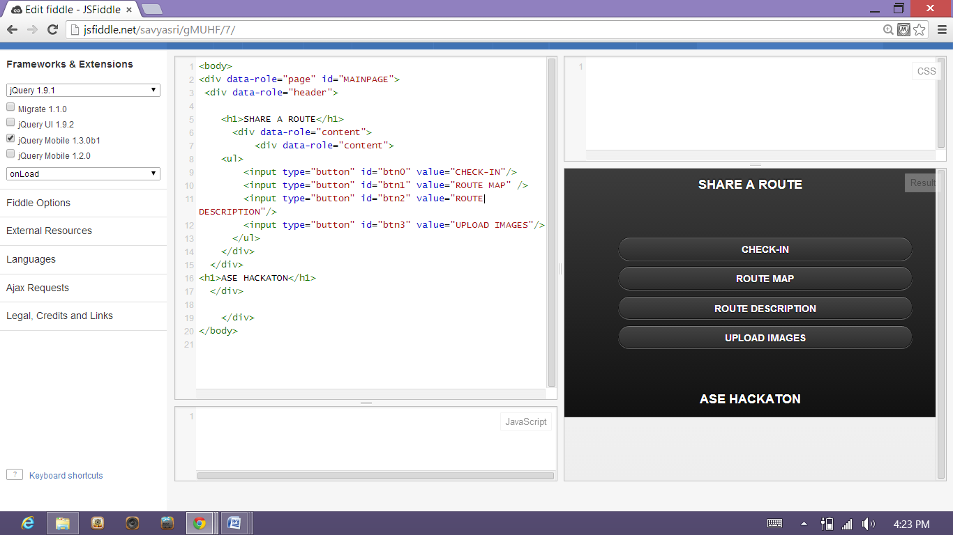

**4)**

**Here trace a route by entering the place and check-in each place**

**Also we have option that start and stop tracing the route in this page**

**Or we can discard everything and we can go to homepage**

**And we can check-in each place by clicking on check-in button.**

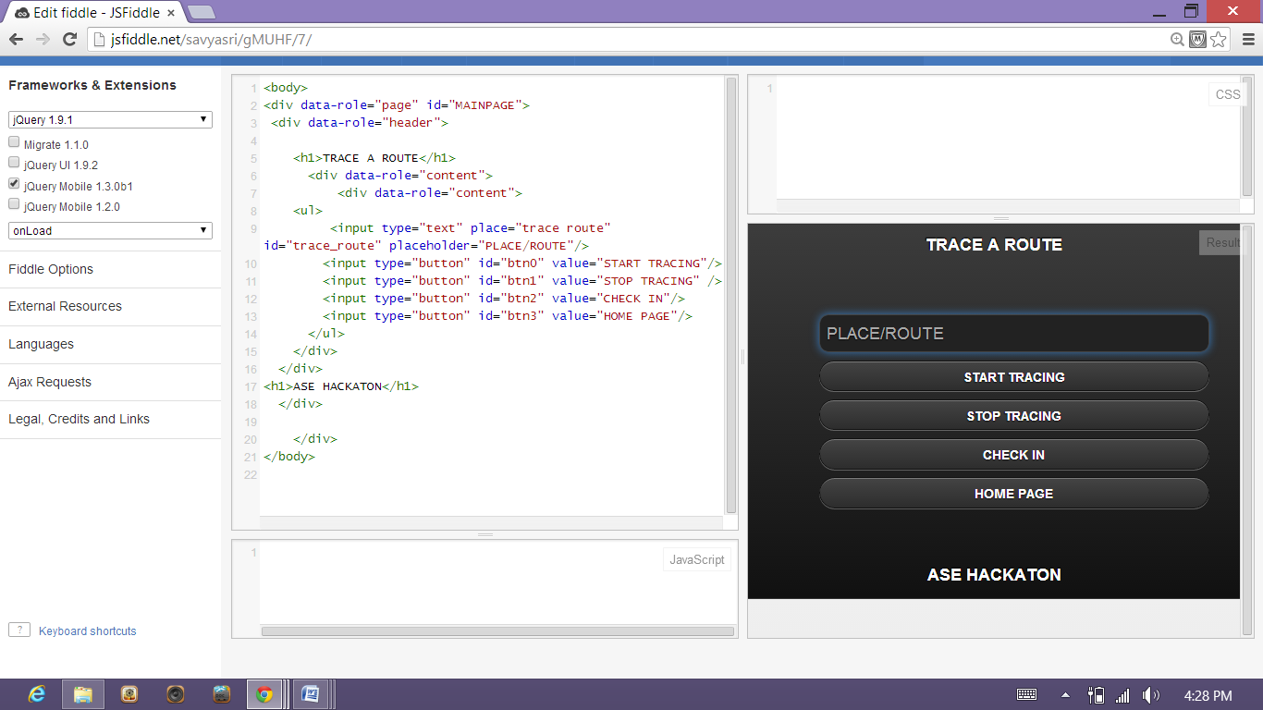

**5)**

**Here is walk through a route page**

**Here we can trace a route or we can find a route of destination by adding place to the destination place and map shows route where user to go and there will be route description, rate of the route and homepage in the same page.**

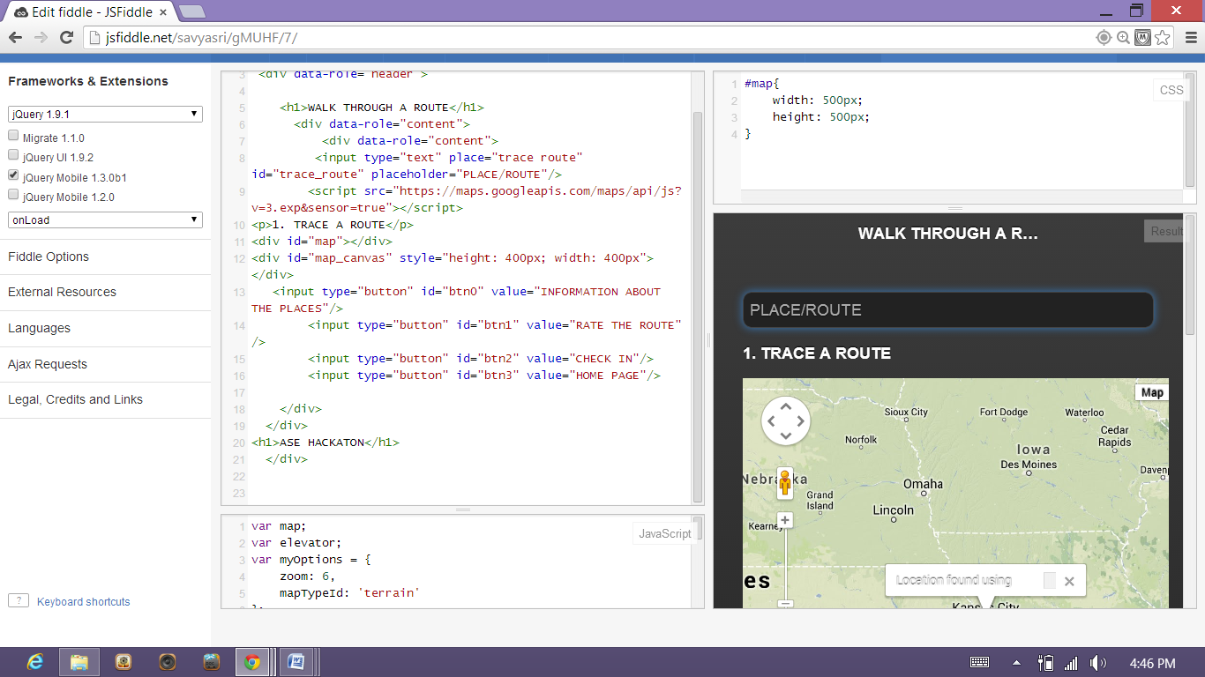

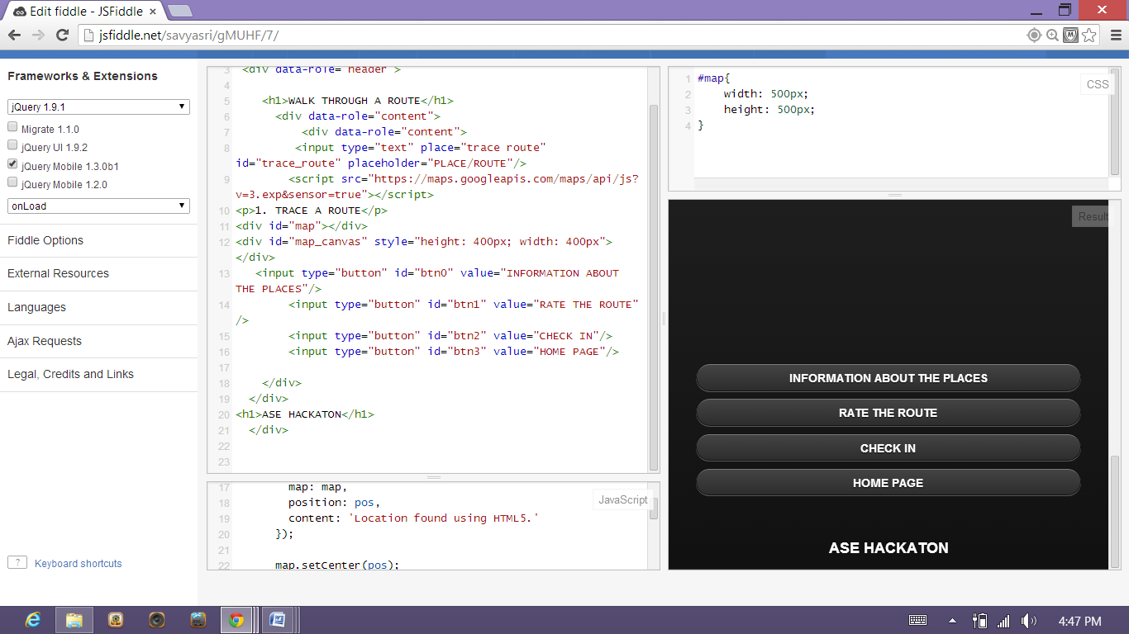

**6)**

**History this is page where user can find his/her history where he travelled which route and check-in places and route everything that he/she done in the past**

**We can search history by clicking any name on search history box.**

**We can clear the browsing data or selected data**

**Or we can go to homepage.**

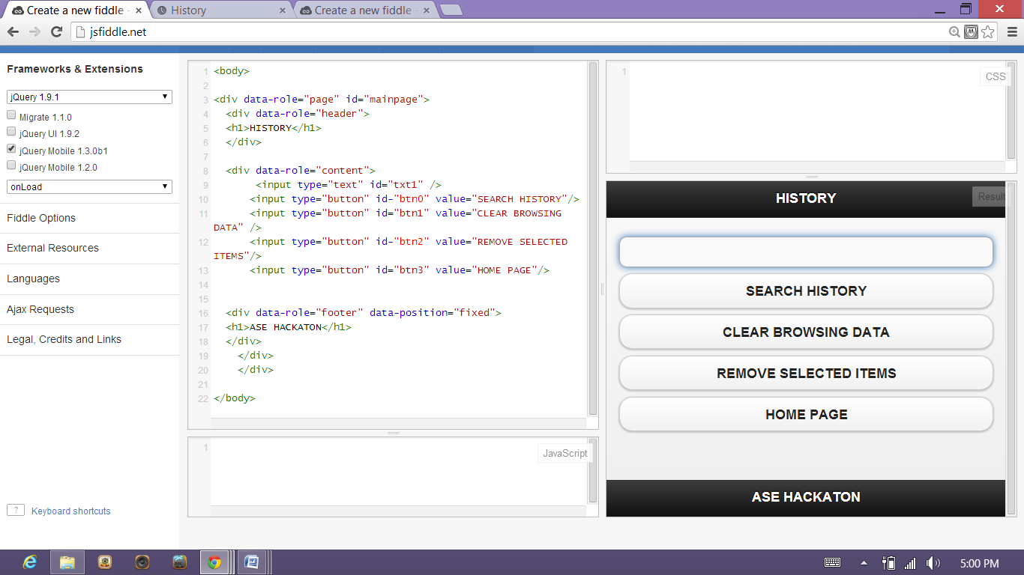

**7)**

**This is the check-in page**

**Where we can check-in current place via social networks like face book , twitter.**

**We can upload photos at each place.**

**We can share the route description or any other status**

**Or we can move on to homepage.**

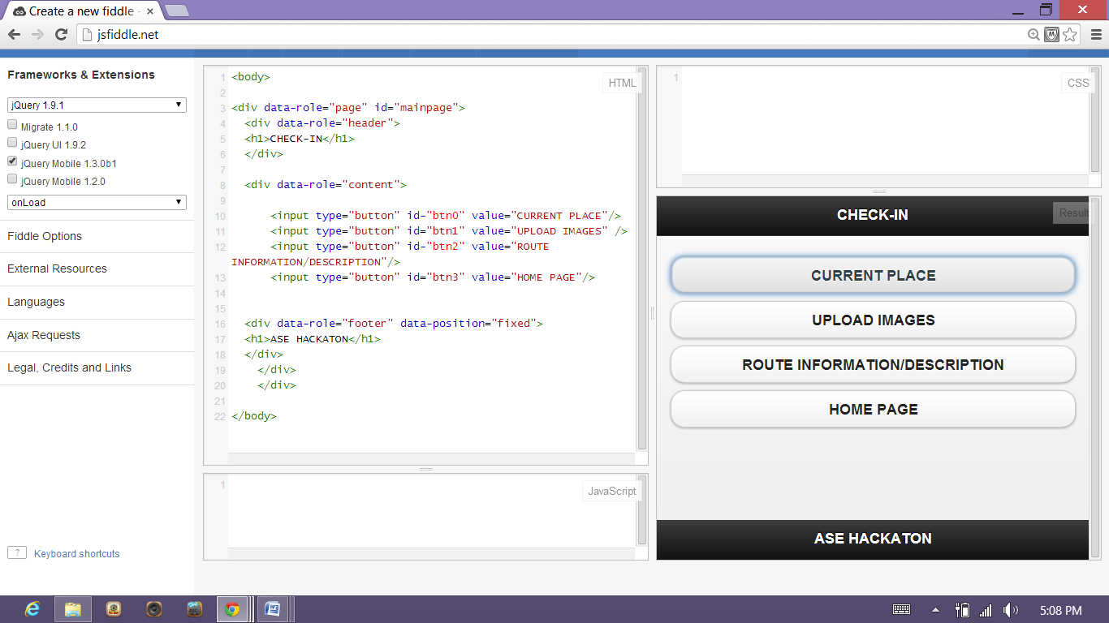

**Limitations:**

**1) If we move back to homepage the unsaved data will be removed.**

**2) We cannot operate multiple places at a time.**

**3) Upload of images, route description, route map cannot be check-in at a time.**

**Reference:**

1) [http://www.codeproject.com/Articles/](http://www.codeproject.com/Articles/37618/Hello-Amazon-Making-a-first-request-to-the-Amazon)

2) http://www.codeproject.com/Forums/1580226/JavaScript.aspx